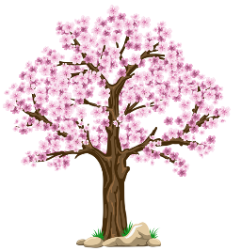
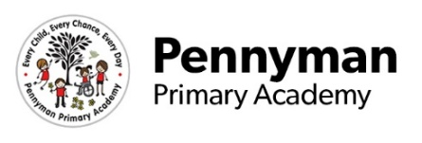
Year 2 Newsletter
Spring 2023

Welcome to our spring newsletter!
We want to share with you some of the fantastic things we will be getting up to in Year 2 in the academy this term.
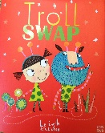  Year 2 English  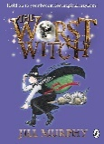  In English this half term we are focusing on the story Troll Swap. The children will be writing character and setting descriptions which will focus on expanded noun phrases and using commas in a list. After half term we shall be writing about owls.  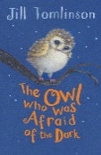  We will continue to practise our sentence writing, really focusing on capital letters and full stops being used accurately. We will also be extending our sentences using and, because. You can help us by getting the children to practise speaking in full sentences.  As our whole class story, we will be reading The Worst Witch and then after half term, The Owl Who Was Afraid Of The Dark. | Year 2 Maths  In Maths we shall be looking at numbers up to 100 and exploring their place value. We shall be learning to use the four operations with these numbers too. Children will be learning to count in 2’s, 3’s, 5’s and 10’s. They need to know these time tables off by heart so your support with this would be helpful.  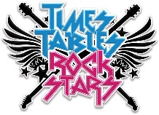  We will be taking part in Winning with Numbers and using Times Table Rockstars daily.  We shall also be exploring shapes and statistics across the term as well as measure.  Please encourage counting at home and whilst you are out and about – maths is everywhere. Children can also practise number formation.
Year 2 Science  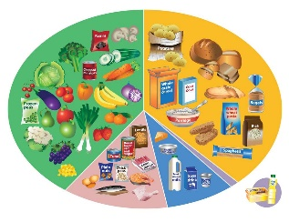  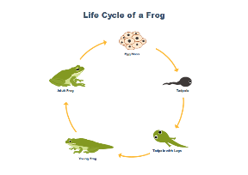  In Science this term, the children will continue to enhance their scientific enquiry skills through their knowledge of animals and humans. The children will develop their understanding of life cycles for animals, plants and humans. They will be able to answer the question of ‘What do humans need to grow and be healthy?’ This will also include the children learning about a healthy balanced diet, exercise and good hygiene. They will also learn about only taking medicines prescribed by doctors. | 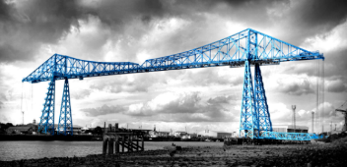  Year 2 Wider Curriculum  During the term, the children will be learning how Middlesbrough has changed in the last 200 years and to compare Middlesbrough to another location in the UK!  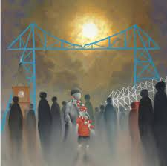  In DT the children will be making vehicles for their trolls which can move. We are very much looking forward to seeing what the children make for their troll and developing their wood work skills!  In Art, the children will learn about Mackenzie Thorpe and how to create their own piece of art work in his style.  In Computing, the children will continue to practise their coding skills on scratch and make movies about owls!
Year 2 Homework  This term, Y2 children will receive weekly homework. Please support your child with their learning and ask a member of the Y2 team if you have any questions. If your child is struggling, then please let us know so that we can support them further. Homework will be given on a Friday to be completed and returned by the following Friday.  Weekly spellings to be tested on a Friday.  Timetable Rockstars- please go on this for at least 30 minutes across the week.  Children are also expected to read daily at home and to complete their reading record with an adult. Children need to read four times at home during the week to earn a golden ticket. | Year 2 Other information  PE will take place on a Monday afternoon. Please send your child into school with their PE uniform: white tshirt, black shorts and trainers. If the weather is cold, please provide your child with a black tracksuit. If children do not come with a Pennyman PE uniform, then they will be provided with one to wear.  Reminder: Children are not permitted to wear jewellery, other than one small pair of stud earrings. On PE days, please ensure that your child is able to remove these independently.  Children can bring a water bottle to school. Please ensure that this only has water and no juice, flavoured water or fizzy drinks.

