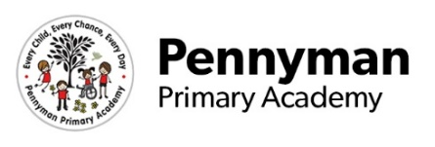
Year 1 Newsletter
Spring 2023

Welcome to our spring newsletter!
We want to share with you some of the fantastic things we will be getting up to in Year 1 in the academy this term.
Year 1 English  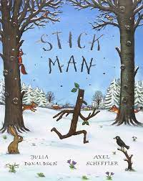  In our first week back, the children have written a recount based on their favourite parts of the Christmas holidays. During the rest of this term, the Y1 children are going to be writing a narrative piece about Julia Donaldson and Axel Scheffler, The Stickman.  Later in the term Year 1 will also be writing instructions and a non-chronological report based around their own research on China, linked with the Geography topic Oceans and Continents. | 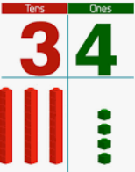  Year 1 Maths  During the first week back, we have investigated doubling numbers using objects, drawings and counting on.  Throughout the Spring term, year 1 will be focussing on recognising, counting, writing and ordering numbers beyond 20 to 100. We will continue counting in 2’s, 5’s and 10’s through song, objects and money.  We will continue learning about the value of digits and be able to recognise tens and ones as well as recognising the time to o’clock and half-past the hour. Encouraging your children to recognise numbers whilst out and about is a great way of reinforcing their recognition of numbers. Counting objects and playing with coins can also help your childs understanding of number greatly.
Year 1 Wider Curriculum  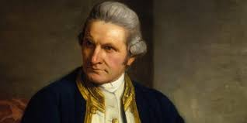  History – Captain Cook  Geography – Continents and oceans  Art – Art inspired by Lucy Pittaway  DT – Bridge building  RE – Christianity - Easter  Computing – Programming  Music – Call and response singing  PSHE – Importance of family and mental health  PE – Net and wall games, and dance.  *PE is taught every Friday morning – please send the appropriate PE kits on or before this day. | Year 1 Science  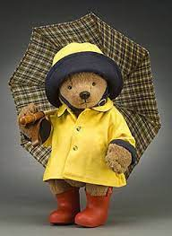  During this term, Y1 will be exploring everyday materials. We will look at a range of materials such as, glass, plastic and wood, and discuss whether they are natural or man-made.  We will begin to look at the properties of materials and use the terminology translucent and opaque. As well as this, we will take part in a materials investigation and explore which materials would make the best raincoat for a teddy bear.  The children will be exploring what materials are suitable for building a bridge during DT lessons.  Any spare boxes and recycling donations would be greatly appreciated.
Year 1 Other information  World Book Day-Thursday 2nd March  Year 1 class trip to Captain Cook Museum- date to be confirmed and further information to follow. | Year 1 Homework  Reading books will continue to be sent home weekly, two phonic group books and one ‘cuddle’, sharing book.  Spellings will continue to be given every Friday for the children to be tested on the following Friday.  Phonic screening test ‘alien word’ practice homework will commence this term- further information to follow.

