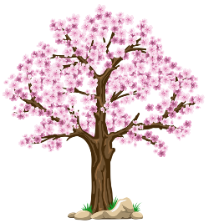
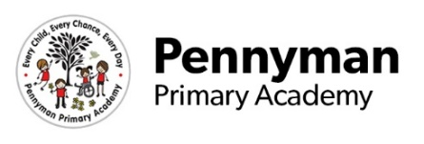
Year 6 Newsletter
Spring 2023

Welcome to our spring newsletter!
We want to share with you some of the fantastic things we will be getting up to in Year 6 in the academy this term.
Year 6 English  This term in Y6, we are exploring the genres of explanation texts, narrative and poetry. We will be looking at how we can use explanations to explain how electrical devices work and linking this to our science topic. We will continue to develop our writing skills by widening our sentence types and developing our use of higher order punctuation, including colons and semicolons.  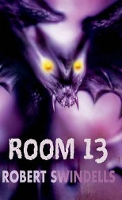  We will develop our reading and comprehension skills by using a wide variety of fiction and non-fiction texts and using  inference skills to answer questions.  Our class novel this half term is ‘Room 13’ by Robert Swindells. | Year 6 Maths  In maths this term, we will begin by extending our knowledge of the four operations and developing our fluency in long multiplication and long division, as well as extending our learning through reasoning and problem-solving activities. Within this topic, children will need a secure knowledge of their times tables to make their learning more efficient. ALL children would benefit hugely from regular practise at home using Times Table Rock Stars.  We will also be developing our knowledge and understanding of fractions further by using factors to simplify and to multiply and divide them by whole numbers and finding fractions, and percentages of amounts.  In addition to this, we will be developing our understanding of measures, coordinates and statistics, where we will read and construct line graphs and solve related problems.
Year 6 Science  This term, our science topic is electricity. We will begin our topic by exploring the history of electricity and how electrical items were invented. We will use scientific enquiry to investigate the brightness of bulbs and use practical equipment to make a variety of circuits. We will also learn the scientific symbols to represent our findings.  Later in the term, children will research the life of famous scientists and use a range of media to present their findings. | Year 6 Wider Curriculum  History- In History, we will delve into the ancient civilisation of the Mayans and discover the factors that led to the empire’s decline.  Geography- In Geography, we will look at what makes the Americans unique, focusing on the human and physical geography within countries in North, South or Central America. In addition to this, we will learn about the varying climates of different regions in South America.  Business Enterprise Task- We will be learning all about sustainability and taking part in a Trust-wide project to design a sustainable Middlesbrough.  PSHRE -We are working hard to develop our resilience and perseverance in different situations to help us to prepare for Y7. We will also develop our well-being and explore a range of strategies to help us to cope when we feel angry and sad, as well as how we can support others.  Art – We will explore the work of Andy Warhol and create images based on his work.
Year 6 Homework  Year 6 children receive weekly spellings and are expected to access Times Table Rock Stars each week. In addition to this, Y6 children will receive additional homework as the year goes on, to prepare them for their SATs and the challenge of Year 7. Children are also expected to read at home regularly and their reading record should be signed by an adult 4 times per week where possible.  Please support your child with this in order to develop their resilience and to prepare them for Year 7. | Year 6 Other information  PE is on a WEDNESDAY afternoon – please send the appropriate PE kits (white t-shirt, black shorts or black tracksuit in cold weather) on or before this day.  Please only send children with plain or flavoured water in their bottles. No fizzy drinks (including sparkling water) or juice please.  We will soon be using apps such as Class Dojo and Boom Reader to improve our home-school communication. Please keep a look out for the letters which will be sent home soon providing information on how you can access these apps.

