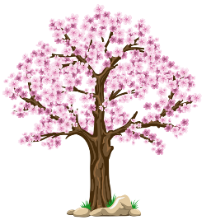
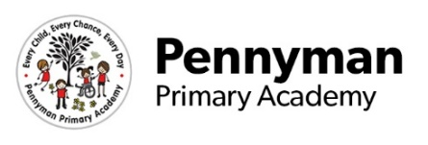
Jeffers Class
EYFS Newsletter
Spring 2023

Welcome to our Spring newsletter!
We want to share with you some of the fantastic things we will be getting up to in SEND EYFS in the academy this term.
It has been wonderful to see how much progress the children have made over the course of their first term in Reception! The children really shone when they learned all about different celebrations - it has been lovely to see them apply their knowledge to their play in the classroom.  This term, we will be exploring the following theme:  All about me and celebrations.  We will be building on the knowledge children gained last year and exploring these topics in further depth. | SEND EYFS Other Information  Please ensure all items of clothing and belongings are labelled clearly with your child’s name. As the wet and cold months start to approach, you are welcome to send your child in a change of footwear for outside play (we may still be out when it is muddy).  We have been named Jeffer’s class after the author and artist Oliver Jeffers. We will be sharing his books in class but if you would like to become more familiar with them, here are some of our favourites:  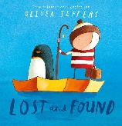  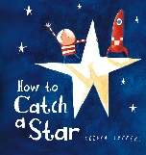  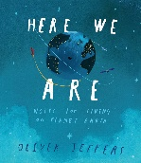
SEND EYFS English  We will be starting programmes such as squiggle while you wiggle and we will be continuing with phonics for those children who are ready. As always, we will foster a love of reading with the children within class but if you would like to loan some of our favourite books from school, please ask for a ‘cuddle book’ and we will send one of your child’s favourites home to share. We will continue to encourage the children to make marks in class and we are specifically looking for them to attach meaning to what they have written be it letters, words or a drawing. | SEND EYFS Maths  In Maths sessions we will continue to share lots of number songs with the children and will begin to develop children’s understanding of counting through this. We will also be developing children’s numeral recognition and basic shape recognition within class.  We will also be exploring other concepts of mathematics through our continuous provision such as capacity and measurement.
SEND EYFS Communication and Language  The children in SEND EYFS love our interactive speech and language sessions which we will move forward with still this year. We have some new speech and language stories such as Peace At Last which the children can’t wait to start with.  We have also introduced sing and sign sessions into our day to familiarise children with Makaton sign language. If you would like to have a go at home too, Singing Hands on YouTube is a fantastic resource. | SEND EYFS Expressive Arts and Design  We will continue to give the children the opportunity to express themselves through arts and crafts within class time.  We explore expressive arts and design through Attention Autism a fantastic programme which develops children’s focus as well as opens the door for artistic work!  We will be learning about the different colours and how they change when they are mixed together as part of our sensory exploration.
SEND EYFS Personal Social and Emotional Development  It has been wonderful to see the children make and build on their friendships as they have continued in reception.  We will continue to support children with their own personal, social and emotional development through our continuous provision.  If you would like some resources at home to support your children such as Now and Next boards, choice boards or symbols. Please let us know and we will be happy to help. | SEND EYFS Physical Development  We have begun taking part in PE sessions where the children have adapted sessions to support them in all aspects of their physical development. We have recently started gymnastics which the children have been loving!  We have started dance sessions to develop children’s core strength and gross motor skills and Dough Disco (available on YouTube if you would like to try at home) for their fine motor skills. The children will continue to use soft play, sensory and our outside provision this year too.

