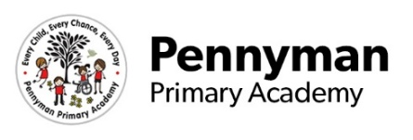
Ahlberg Class
LKS2 Newsletter
Spring 2023

Welcome to our spring newsletter!
We want to share with you some of the fantastic things we will be getting up to in LKS2 in the academy this term.
LKS2 English  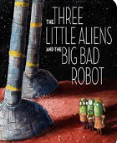  This term we are going to be focusing on writing full sentences using the story ‘The Three Little Aliens and the Big Bad Robot’. We will rewrite the story, focusing on capital letters, fingers spaces and our vocabulary choices. We will also be writing a recount based on a visit to a local shop to purchase the ingredients  needed to make our own pizzas.  Then, we will move on to writing  instructions to explain how to  make your own healthy pizza. | LKS2 Maths  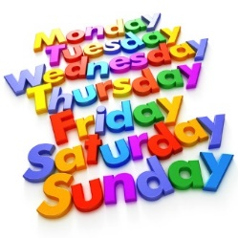  In maths this term we will be focusing on number, space, shape and measure, and using and applying our skills. Across our class, pupils will be looking at addition and subtraction, place value and using ordinal numbers. Moreover, we will be exploring 2D and 3D shapes, and looking at their number of faces, edges and vertices. Days of the week will also be a focus throughout this term so please encourage your child to discuss what day it is and which day was yesterday and which is tomorrow.
LKS2 Science  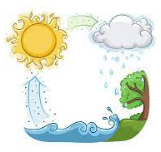  In Science this term, we will be learning about materials and how they can change state. Our lessons will explore solids, liquids and gases, and how we can recognise these from their properties. Moreover, we will learn about the water cycle and identify how heating and cooling plays its part in the processes. | LKS2 Wider Curriculum  There are lots of topics for us to cover throughout the Spring term. We have started with our geography and art topics, and we have learned about the different climates of the Earth as well as the sculptures of Antony Gormley. We will continue exploring sculptures in art and we will create our own using clay. In DT, we will learn to make a healthy pizza and in RE, we will explore both Christianity and Islam faiths. Throughout this term, we will also learn about the Pennyman family and their impact on our school community.
LKS2 Homework  We ask that you read with your child at least 4 times a week, this can include your cuddle book or library book, to consolidate and extend their learning. Those children who have read 4 times a week will be awarded a golden ticket and entered in to a prize draw. Additionally, we will be completing a weekly spelling test so please support your child to learn their words at home. | LKS2 Other information  Happy New Year!  We have PE on a Monday so please ensure your child’s kit is in their bag. Please ensure your child has a water bottle in their bag every day.  Thank you for your continued support and if you have any queries or questions, either pop it in your child’s communication book or phone the office and I will happily call you back.

