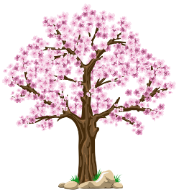
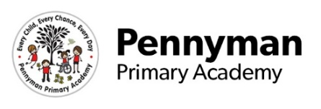
Year 5 Newsletter
Spring 2023

Welcome to our spring newsletter!
We want to share with you some of the fantastic things we will be getting up to in Year 5 in the academy this term.
Year 5 English  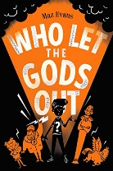  This term in Year 5, we will be continuing to develop our narrative writing skills based on our curriculum topics, where we will be writing our own myths and mystery stories. We will also be linking our non-fiction writing – such as instructions and recounts – to our science and design and technology topics.  Our reading lessons will focus on developing our retrieval skills and using evidence from the text to support inference answers. Our class novel this term is ‘Who Let the Gods Out’ by Maz Evans. | Year 5 Maths  In maths this term, we will be continuing to develop our understanding of calculation, fractions, measurement and geometry. We will be practising formal written methods of multiplication and division, multiplying fractions by whole numbers and learning the place value of thousandths. We will also be learning about percentage and how this relates to fractions, as well as converting between different units of measure.
Year 5 Science  This term, our science topic is Earth, Sun and Moon. We will learn about the solar system and how we know that the Earth, Sun and Moon are spherical. We will also learn about other planets and how their orbits differ.  Children will use their investigative skills to find out how the sun affects shadows and why the appearance of the moon changes. | Year 5 Wider Curriculum  History - The Ancient Greeks. Children will learn about how Ancient Greece was divided into states and what life was like in Ancient Greece.  Geography – Children will learn about the different climates and biomes around the world.  PSHRE – We will be learning about commitment: what it is and how people may show it to one another. We will also develop ways to help us in times when we feel lonely and sad as well as developing our understanding of bullying and how this affects our wellbeing.  Computing – We will use the software ‘Reality Composer’ to create a project with an Ancient Greek theme.  Art – We will explore the work of Peter Thorpe and use his painting style to create space backgrounds.
Year 5 Homework  Spellings - Children receive their weekly spellings on Mondays which they are expected to practice for their test on Fridays. The children do not need to practice their spellings into the spelling book but could instead recite them to an adult or write them out on some paper when practising at home  Reading – Children should read regularly at home and record in their reading record at least 4 times per week. This will be checked in class and children will receive a ‘Golden Ticket’ and an entry into the prize draw.  Times Tables – At least 40 mins a week practice on Times Tables Rockstars. | Year 5 Other information  PE is on a Tuesday afternoon – please send the appropriate PE kits (white t-shirt, black shorts/leggings/jogging bottoms) on or before this day.  Please only send children with plain or flavoured water in their bottles. No fizzy drinks (including sparkling water) or juice please.  We will soon be using apps such as Class Dojo and Boom Reader to improve our home-school communication. Please keep a look out for the letters which will be sent home soon providing information on how you can access these apps.

