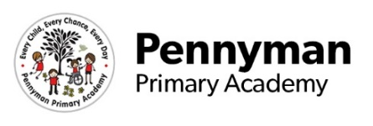
SEND Nursery Newsletter
Spring 2023

Welcome to our spring newsletter!
We want to share with you some of the fantastic things we will be getting up to in Year 6 in the academy this term.
Nursery English  In spring term, we will begin to add marks to our work to show meaning.  We will carry on exploring books through sharing them as a group as well as having time to explore them independently throughout the day. We will be focusing on rhyme and repetition in books such as ‘Going on a bear hunt’ | Nursery Maths  As part of the maths curriculum we will start to look at comparing quantities and being able to use the correct vocabulary such as more and less.  We will also look at cardinal values to three and also counting groups to three.  We want to also build on this knowledge and make sure that pupils can also understand that the numeral represents a set amount.  We will introduce 3D shapes and the use of language associated with this.
Nursery PHSE  The focus of this terms PHSE lessons will be to begin to understand our emotions and the way that we feel.  We want to build on the strong friendships that we have developed within the autumn term and use these to develop skills such as sharing and being able to work in a group effectively. | Nursery Wider Curriculum  To follow on from looking at celebrations in our understanding of the world lessons, we will learn about Chinese New Year and Easter.  We will continue to look at seasons and how this affects the weather; this term looking at winter and spring.  In art, we will explore the use of different materials within our art work. As well as this we will also look at emotions and representing these within our art work.
Nursery Homework  We will carry on sending home ‘cuddle books’ for you to enjoy. These are something you can share and read to your child so that they can begin to explore reading books for pleasure. Once you have enjoyed the book you can send it back and your child can pick another book that they are interested in. | Nursery Other information  We have our PE lesson for half an hour on a Tuesday morning. These sessions will be tailored to suit our classroom to ensure all children have the chance to participate.  During the spring term it will be very muddy and wet. We like to get pupils out as much as possible so it would be great if you could send in coats and wellies. Thank you!  