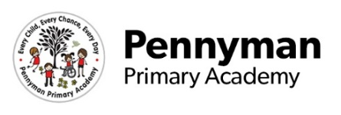
Donaldson Class Newsletter
Spring 2023

Welcome to our spring newsletter!
We want to share with you some of the fantastic things we will be getting up to in Donaldson class in the academy this term.

Donaldson Class English  In spring term, we will begin our new class book Aliens Love Underpants! We will continue developing our ability to retell and sequence our favourite stories. This term we will also be learning all about making a set of instructions, so that we can complete different activities such as making our own sandwich. | Donaldson Class Maths  Our class will be enjoying lots of hands on practical tasks within our learning zones that allow us to practice and extend our maths skills and understanding. We will continue developing independent strategies to increase our confidence and fluency in mathematics so that we can become number happy.  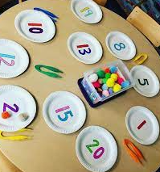  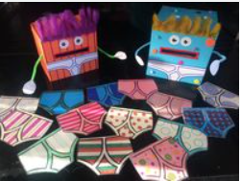  We will also revisit and build upon our knowledge of shape and colour, big and small.  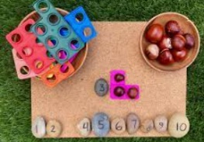
Donaldson Class PHSE  The focus of this terms PHSE lessons will be to begin to understand what family means and why being healthy is so important to us.  We will continue to build on our understanding of our emotions and the importance of kindness and friendships. | Donaldson Class Curriculum  This term we have lots of exciting topics to learn about. In geography we will be looking at the area that we live and comparing it to the city of London. In our science lessons we will be learning what we need to do so that we grow and are healthy. The artist we will be studying is Mackenzie Thorpe.  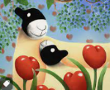
Homework  We will carry on sending home ‘cuddle books’ for you to enjoy. These are something you can share and read to your child so that they can begin to explore reading books for pleasure. Once you have enjoyed the book you can send it back and your child can pick another book that they are interested in. | Other information  We have our PE lesson for half an hour on a Monday morning. These sessions will be tailored to suit our classroom to ensure all children have the chance to participate.  During the spring term it will be cold and wet. Please ensure your child comes to school in a warm coat so that we can continue our learning outside.  Thank you!  