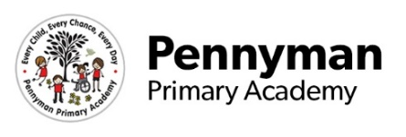
Reception Newsletter
Spring 2023

Welcome to our spring newsletter!
We want to share with you some of the fantastic activities your children will be completing in Reception this term. Children will be learning …
Literacy  Writing  - To write their name.  - To write CVC words like bed, dog, cat.  - To write simple captions like ‘The red bus.’  Reading  - To recognise sounds from Read Write Inc.  - To play segmenting and blending games.  - To read CVC words.  - To read simple sentences, when ready.  - To celebrate World Book Day. | Maths  - To count confidently with objects up to 10.  - To recognise numbers 0 – 10.  - To order numbers 0 – 10.  - To recognise, name and talk about 2D shapes.  - To understand what length, capacity and weight mean and use appropriate vocabulary.
Communication and Language  - To speak in a full sentence.  - To answer a question confidently.  - To begin to ask appropriate questions. | Expressive Arts and Design  - To talk about the differences in drawing and painting.  - To use different media like chalk, charcoal and pastels to create pictures.  - To produce work in the style of different artists.
Understanding of the World  - To understand the changes that happen from autumn to winter.  - To learn about how and why Chinese New Year is celebrated.  - To discuss how toys have changed over time using the words past and present.  - To learn about why people celebrate Easter. | Personal, Social and Emotional Development  - To fasten their own coat.  - To get changed for PE independently.  - To share resources and play a game with a friend.  - To express their feelings to a friend or an adult.
Physical Development  Gross Motor Skills  - To take part in orienteering and athletics in PE.  - To learn how to kick, throw, catch and roll a ball.  Fine Motor Skills  - To strengthen muscles in fingers and hands by participating in daily dough disco and funky fingers activities.  - To use scissors correctly.  - To hold a pencil correctly and to form letters using the correct formation. | Other information  - PE day – Tuesday. Please ensure a named kit is brought into school as soon as possible in January. This will remain in school till half term.  - Golden Tickets – Please read on 4 different nights a week to receive a golden ticket on a Friday.  - Chinese New Year celebrations – 22nd February 2023.  - World Book Day – March 2023. Date to be confirmed.

