Mrs L Stogdale

BAEd (Hons), MEd

Head of Academy

5th November 2021
CHRISTMAS RAFFLE

We are running a Christmas raffle again this year, the tickets are 20p each or £1 a strip. Please find attached 2 strips of raffle tickets for you or your family members to purchase.

If you would like to buy these, please put on the reverse of each ticket the name of your child. Please can you return one side only to the academy with the money no later than Thursday 25th November 2021. Please keep one side of the tickets for your reference.

The raffle will be drawn on Friday 26th November 2021.

PRIZES INCLUDE

1ST PRIZE 32” TELEVISION

2ND PRIZE TASSIMO COFFEE MACHINE

3RD PRICE ECHO DOT

FOOD HAMPER
TOY HAMPERS
TOILETRY GIFT SETS
CUDDLY TOYS
WINE, CHOCOLATES, BISCUITS
& MORE

MORE TICKETS ARE AVAILABLE IN THE ACADEMY

All funds raised by this raffle will go towards opportunities for the children during the spring term.

CHRISTMAS HOLIDAYS

May I take this opportunity to remind you that the academy will break up for the Christmas Holidays on Thursday 22ND December 2021. The academy will re-open Monday 10th January 2022.

Yours sincerely
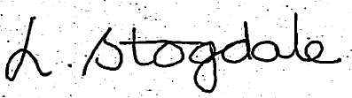

Mrs L Stogdale

Head of Academy

