Mrs L Stogdale

BAEd (Hons), MEd

Head of Academy

Dear Parent(s)/Carer(s),

Welcome back to Pennyman- I hope that you and your families have had a restful summer. We are very much looking forward to the start of this academic year in what will hopefully be a normal school year. The children look very smart in their uniforms and look eager to start next year of learning. We are pleased to say that we will not need to keep children in consistent groups (bubbles). This means that the bubble system has stopped and both the children and staff across the academy will be able to mix, as they did before COVID rules were introduced.

Moving forward, however, we may have to respond to local public health advice at short notice meaning some restrictive measures may be put back into place. Should this happen, we would update you, through all regular channels of text messaging, letters and website announcements.

Increased hand hygiene, the use of hand sanitisers, good ventilation and additional cleaning will continue in the academy, in order to reduce the spread of viruses and bugs.

We are very much looking forward to being able to welcome parents back onto site this academic year and being able to host our annual events. Keep an eye out for letters inviting parents in for special events and to celebrate the work of the children, who we know missed being able to do that with you last year.

Times of the day
The start and finishing times for school have reverted back to previous times pre-pandemic, with all children needing to be in school by 8.50am. Anyone arriving after this time will be marked late. See below for information for each year group.

Year | Start | Finish | Entry | Exit
Reception  (2nd and 3rd September) | 8.40am | 1.00pm | EYFS/ KS1 front gate  (one-way system) | EYFS/KS1 side gate  (one-way system)
Reception  (from 6th September) | 8.40am | 3.00pm | EYFS/ KS1 front gate  (one-way system) | EYFS/ KS1 side gate  (one-way system)
Y1 & 2 (KS1) | 8.40am | 3.00pm | EYFS/KS1 front gate  (one-way system) | EYFS/ KS1 side gate  (one-way system)
Y3, 4, 5 & 6 (KS2) | 8.40am | 3.05pm | KS2 gate 1  (one-way system) | KS2 gate 2  (one-way system)

We ask that you do not gather on the playgrounds, and do not arrive early to drop off or collect your children - we ask this as we are being extremely mindful of large crowds. The gates will open at 8.35am on the morning and 2.55pm (Reception & KS1) and 3.00pm (KS2). On the KS2 playground, please do not go beyond the blue fence, your child’s teacher will bring them out to you.

We will have signs and additional adults out to support with the above.

Uniform & Shoes:
The children are looking smart in their new uniforms but we would like to remind you all that we expect to see all of the children in the correct Pennyman uniform. Please see below the uniform requirements:

- Red cardigan or jumper (it does not have to have the academy logo on)
- Red or White shirt, blouse or polo shirt
- Grey trousers/skirt/pinafore (no jogging bottoms or jeans).
- Red/grey tartan skirt or pinafore
- Plain ankle or knee-high socks or plain tights (grey, black, white or red).
- Red and white striped or checked summer dresses may be worn in the summer (between March and October).
- Grey shorts in summer for boys and girls. NO cycling shorts, cut-offs, leggings or long, baggy Bermuda style shorts.
- Flat, plain black school shoes or trainers - NO bold sole’s / logos. NO heels.
- Close fitting flat black ankle boots.
- Shoes prescribed as part of a medical condition.
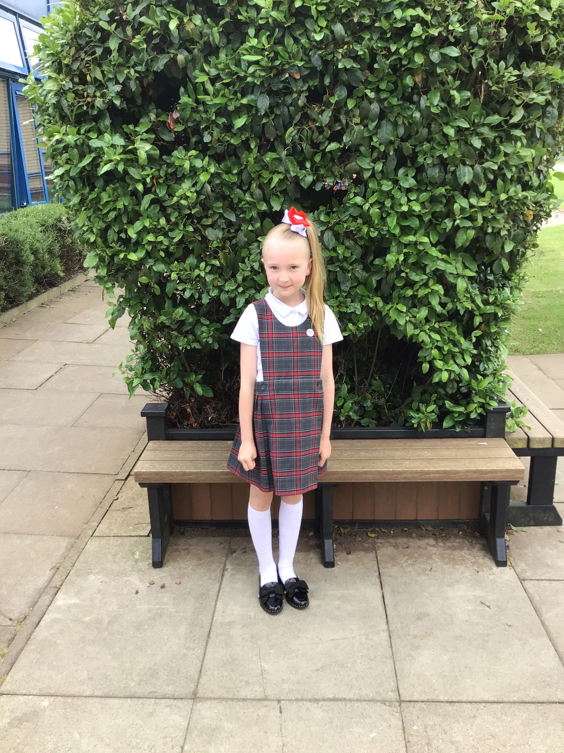
- Children are welcome to bring a change of appropriate footwear for break and lunchtimes.

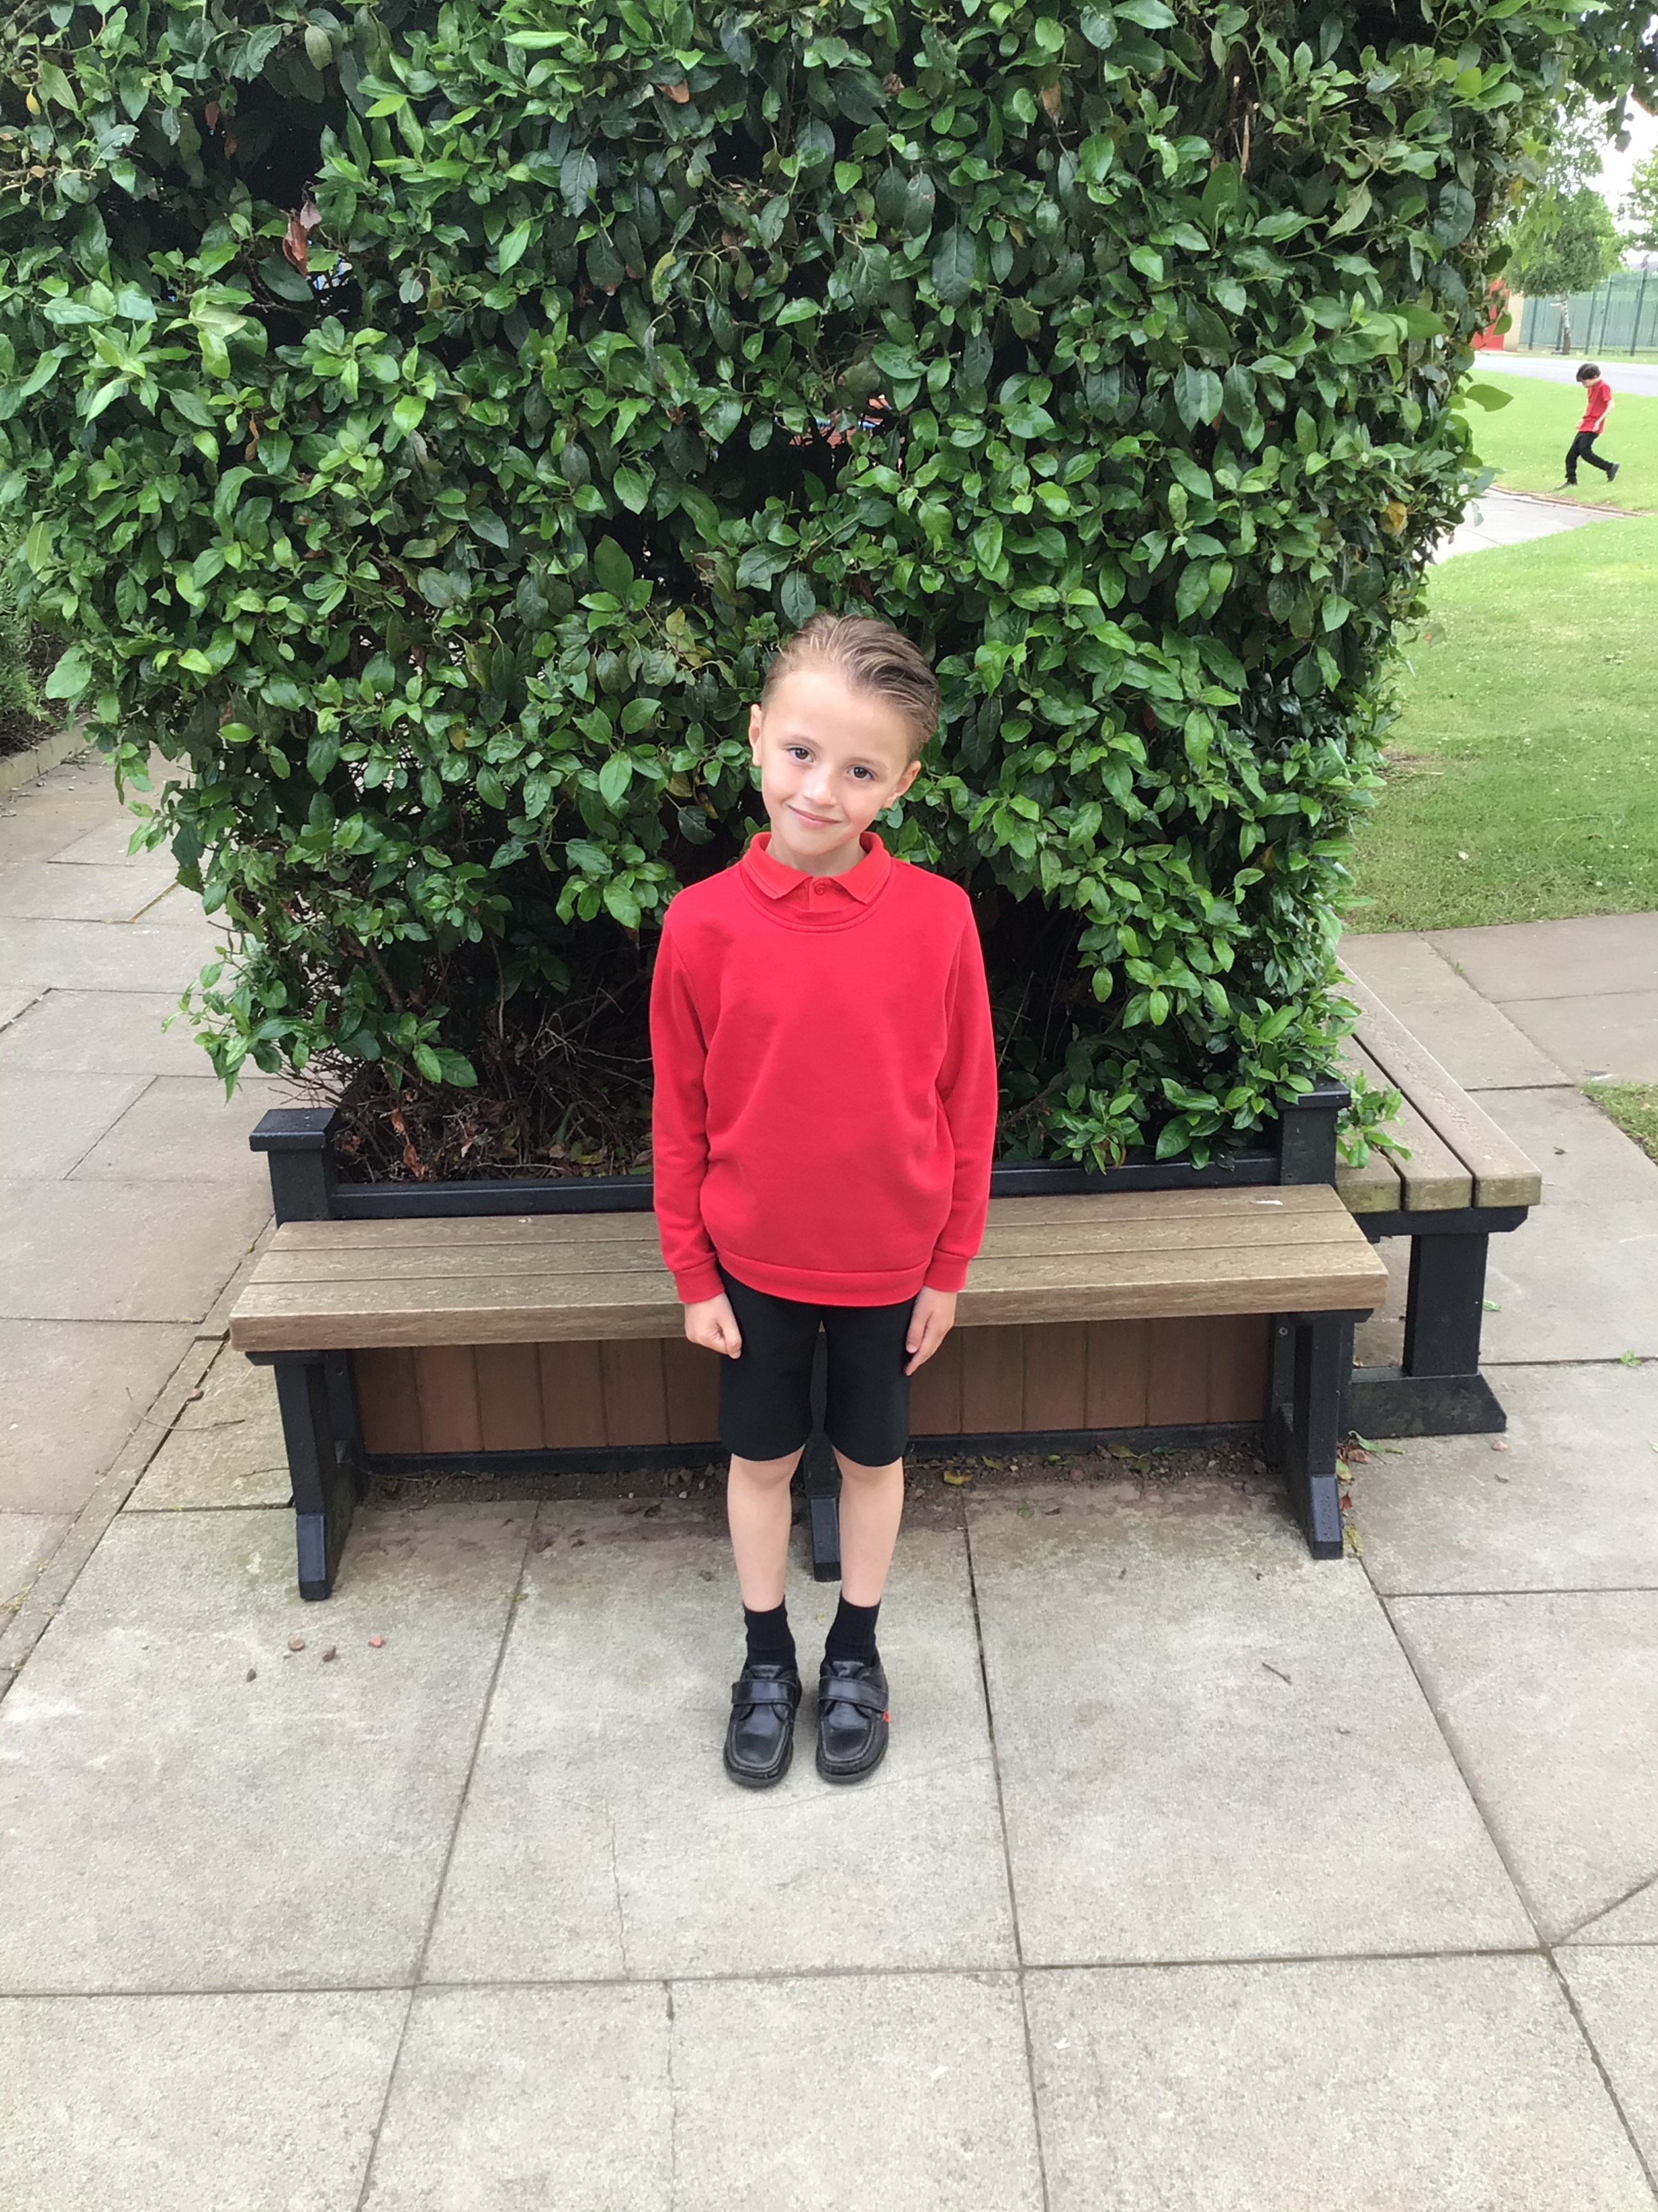
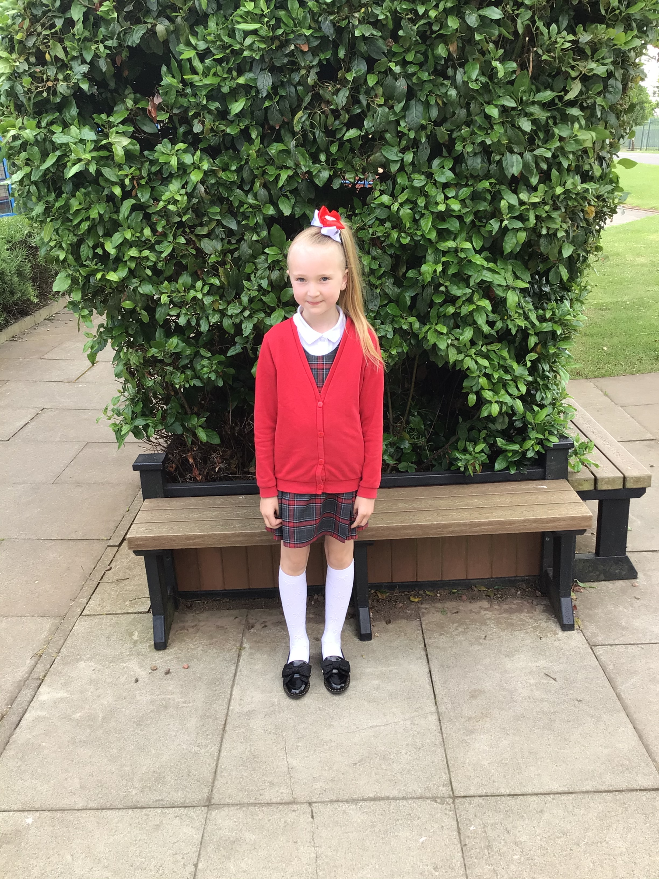
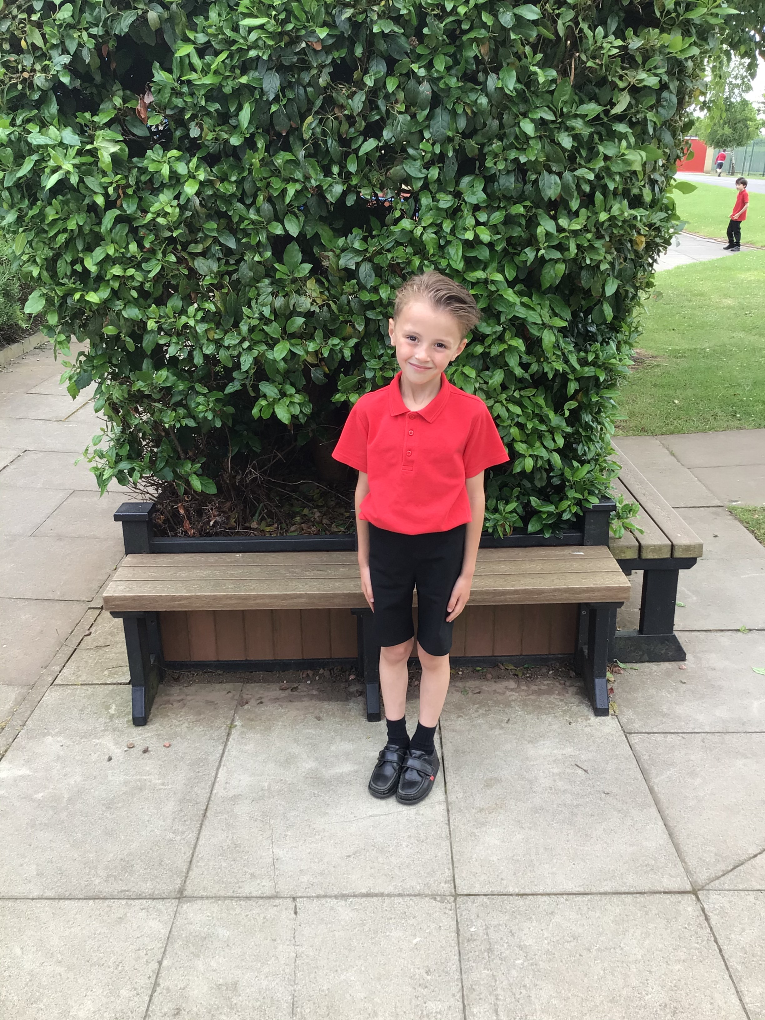
Hair Styles:
Boys are requested to wear smart hairstyles. No shaven patterns or radical styles. Girls with long hair will be encouraged to tie it back.

PE
PE kits need to be in school for their PE session, which will be shared with you in September. Space is limited in school so it would be beneficial if the children could bring their kits in a small bag. Please send your PE kit in on the 2nd September. We will send PE kits home on a regular basis for a refresh. Please see below the updated PE Kit for this academic year, which was sent to you in the summer term.

Year | Day of PE | Year | Day of PE
Nursery SEND | Wednesday | Year 1/2 SEND | Thursday
Reception SEND | Wednesday | Year 3/4 SEND | Thursday
Nursery AM | Monday | Year 3 | Thursday
Nursery PM | Tuesday | Year 4 | Monday
Reception | Tuesday | Year 5 | Wednesday
Year 1 | Friday | Year 6 | Friday
Year 2 | Tuesday | Year 5/6 SEND | Thursday

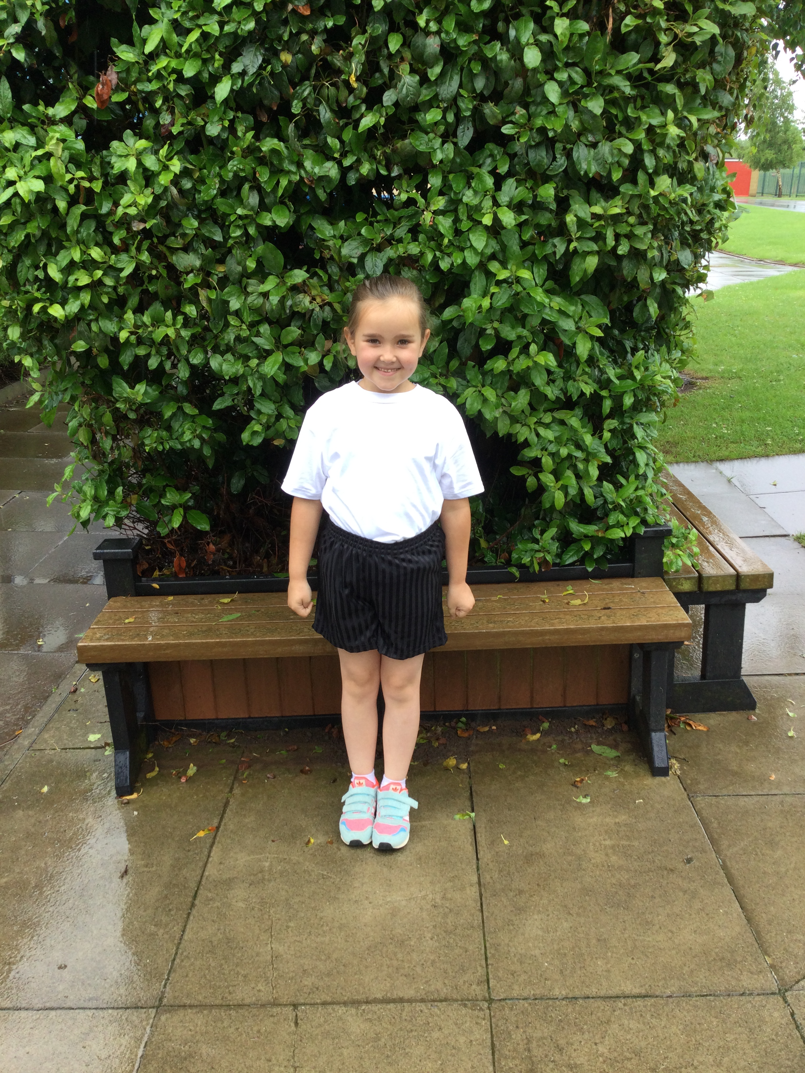
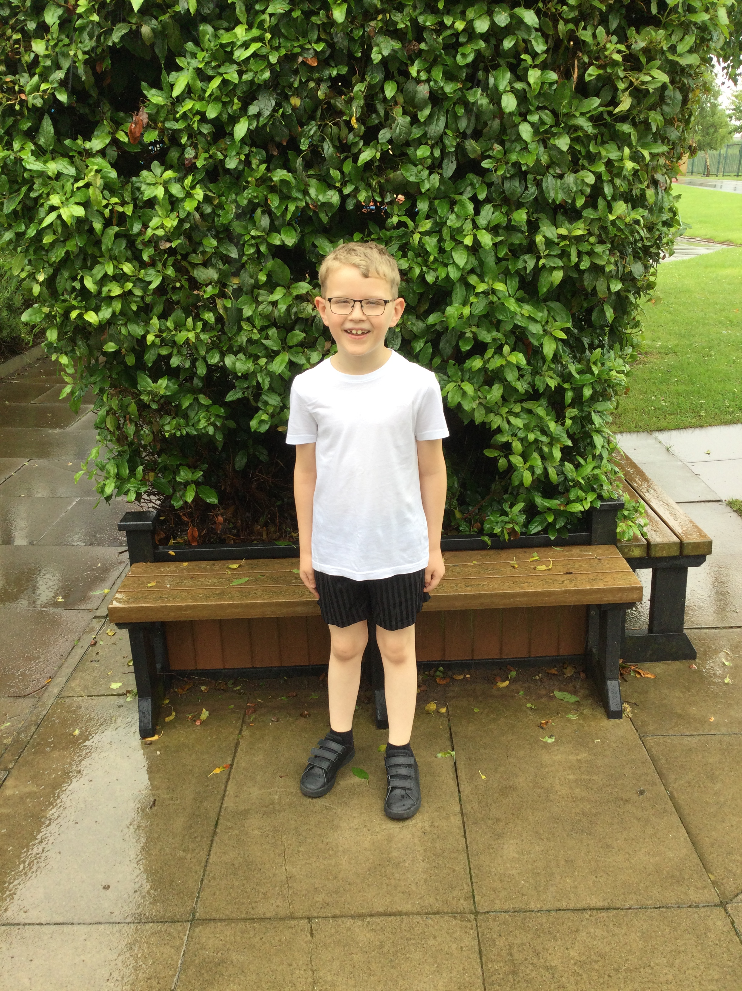
- Plain white t-shirt
- Plain black shorts or joggers
- Plain black fleece (in case it’s cold)
- Change of suitable shoes

I ask that you ensure your child attends Pennyman in line with the policy as expected. Should you have any queries regarding the policy, please do not hesitate to use the website, speak to your child’s teacher, call the office, or make an appointment to see me.

You can purchase all uniform, book bags, PE kits etc. from Lollipops (our uniform supplier). They are based at Norfolk Shops and their contact number is 01642 225827. Equally, most local supermarkets supply uniform too.

School Meals
From the 2nd September, there is an increase to the cost of a school meal. A meal will now cost £2.10 per day, totalling £10.50 per week. Dinner money envelopes are available from the office, please contact us and we can send them home with your child. We would also ask, where possible, you send in the correct money. This really supports the ladies in the office and makes their job a little bit quicker.

Water Bottles
Children can bring water bottles into the academy containing only water. Fresh water is available for the children to put into their bottles as required, please ensure their bottles are named. Children can take bottles home to clean but it is their responsibility to return the bottle to the academy. We can also provide beakers so the children have access to water on a daily basis.

Breakfast Club
Breakfast club will resume from Monday 6th September. Please ensure you have completed a booking form to book your child/children a space. Breakfast club will be 50p a day.

Mobile Phones
If older children (Year 5/6 only) need to bring a mobile phone into the academy, they will be asked by their teacher to put this is in a clear plastic wallet, to be stored safely for them for the day. It should not be taken to the office. If possible, please can you encourage your child to turn off their device as they enter the school grounds.

Medication and Asthma
Now that restrictions are easing, we are able to administer medication once again. This medication must be prescribed by a GP and be clearly labelled with the child’s name from the pharmacist. If your child requires emergency / regular medication, please contact Mr Hunter to make further arrangements. Please ensure an in-date inhaler is in the academy on the 2nd September 2021 if your child requires one.

Reading
We are asking children to bring their book bags in to school on a daily basis along with their reading records. Please continue to support your child with their reading as it is so important to their progress in all areas across the curriculum. The staff are so excited to share the reading records again with parents/ carers and to continue the love of reading together as a joint partnership.

Best Wishes,
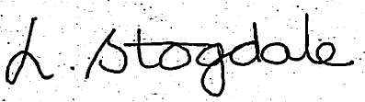

Mrs Stogdale

