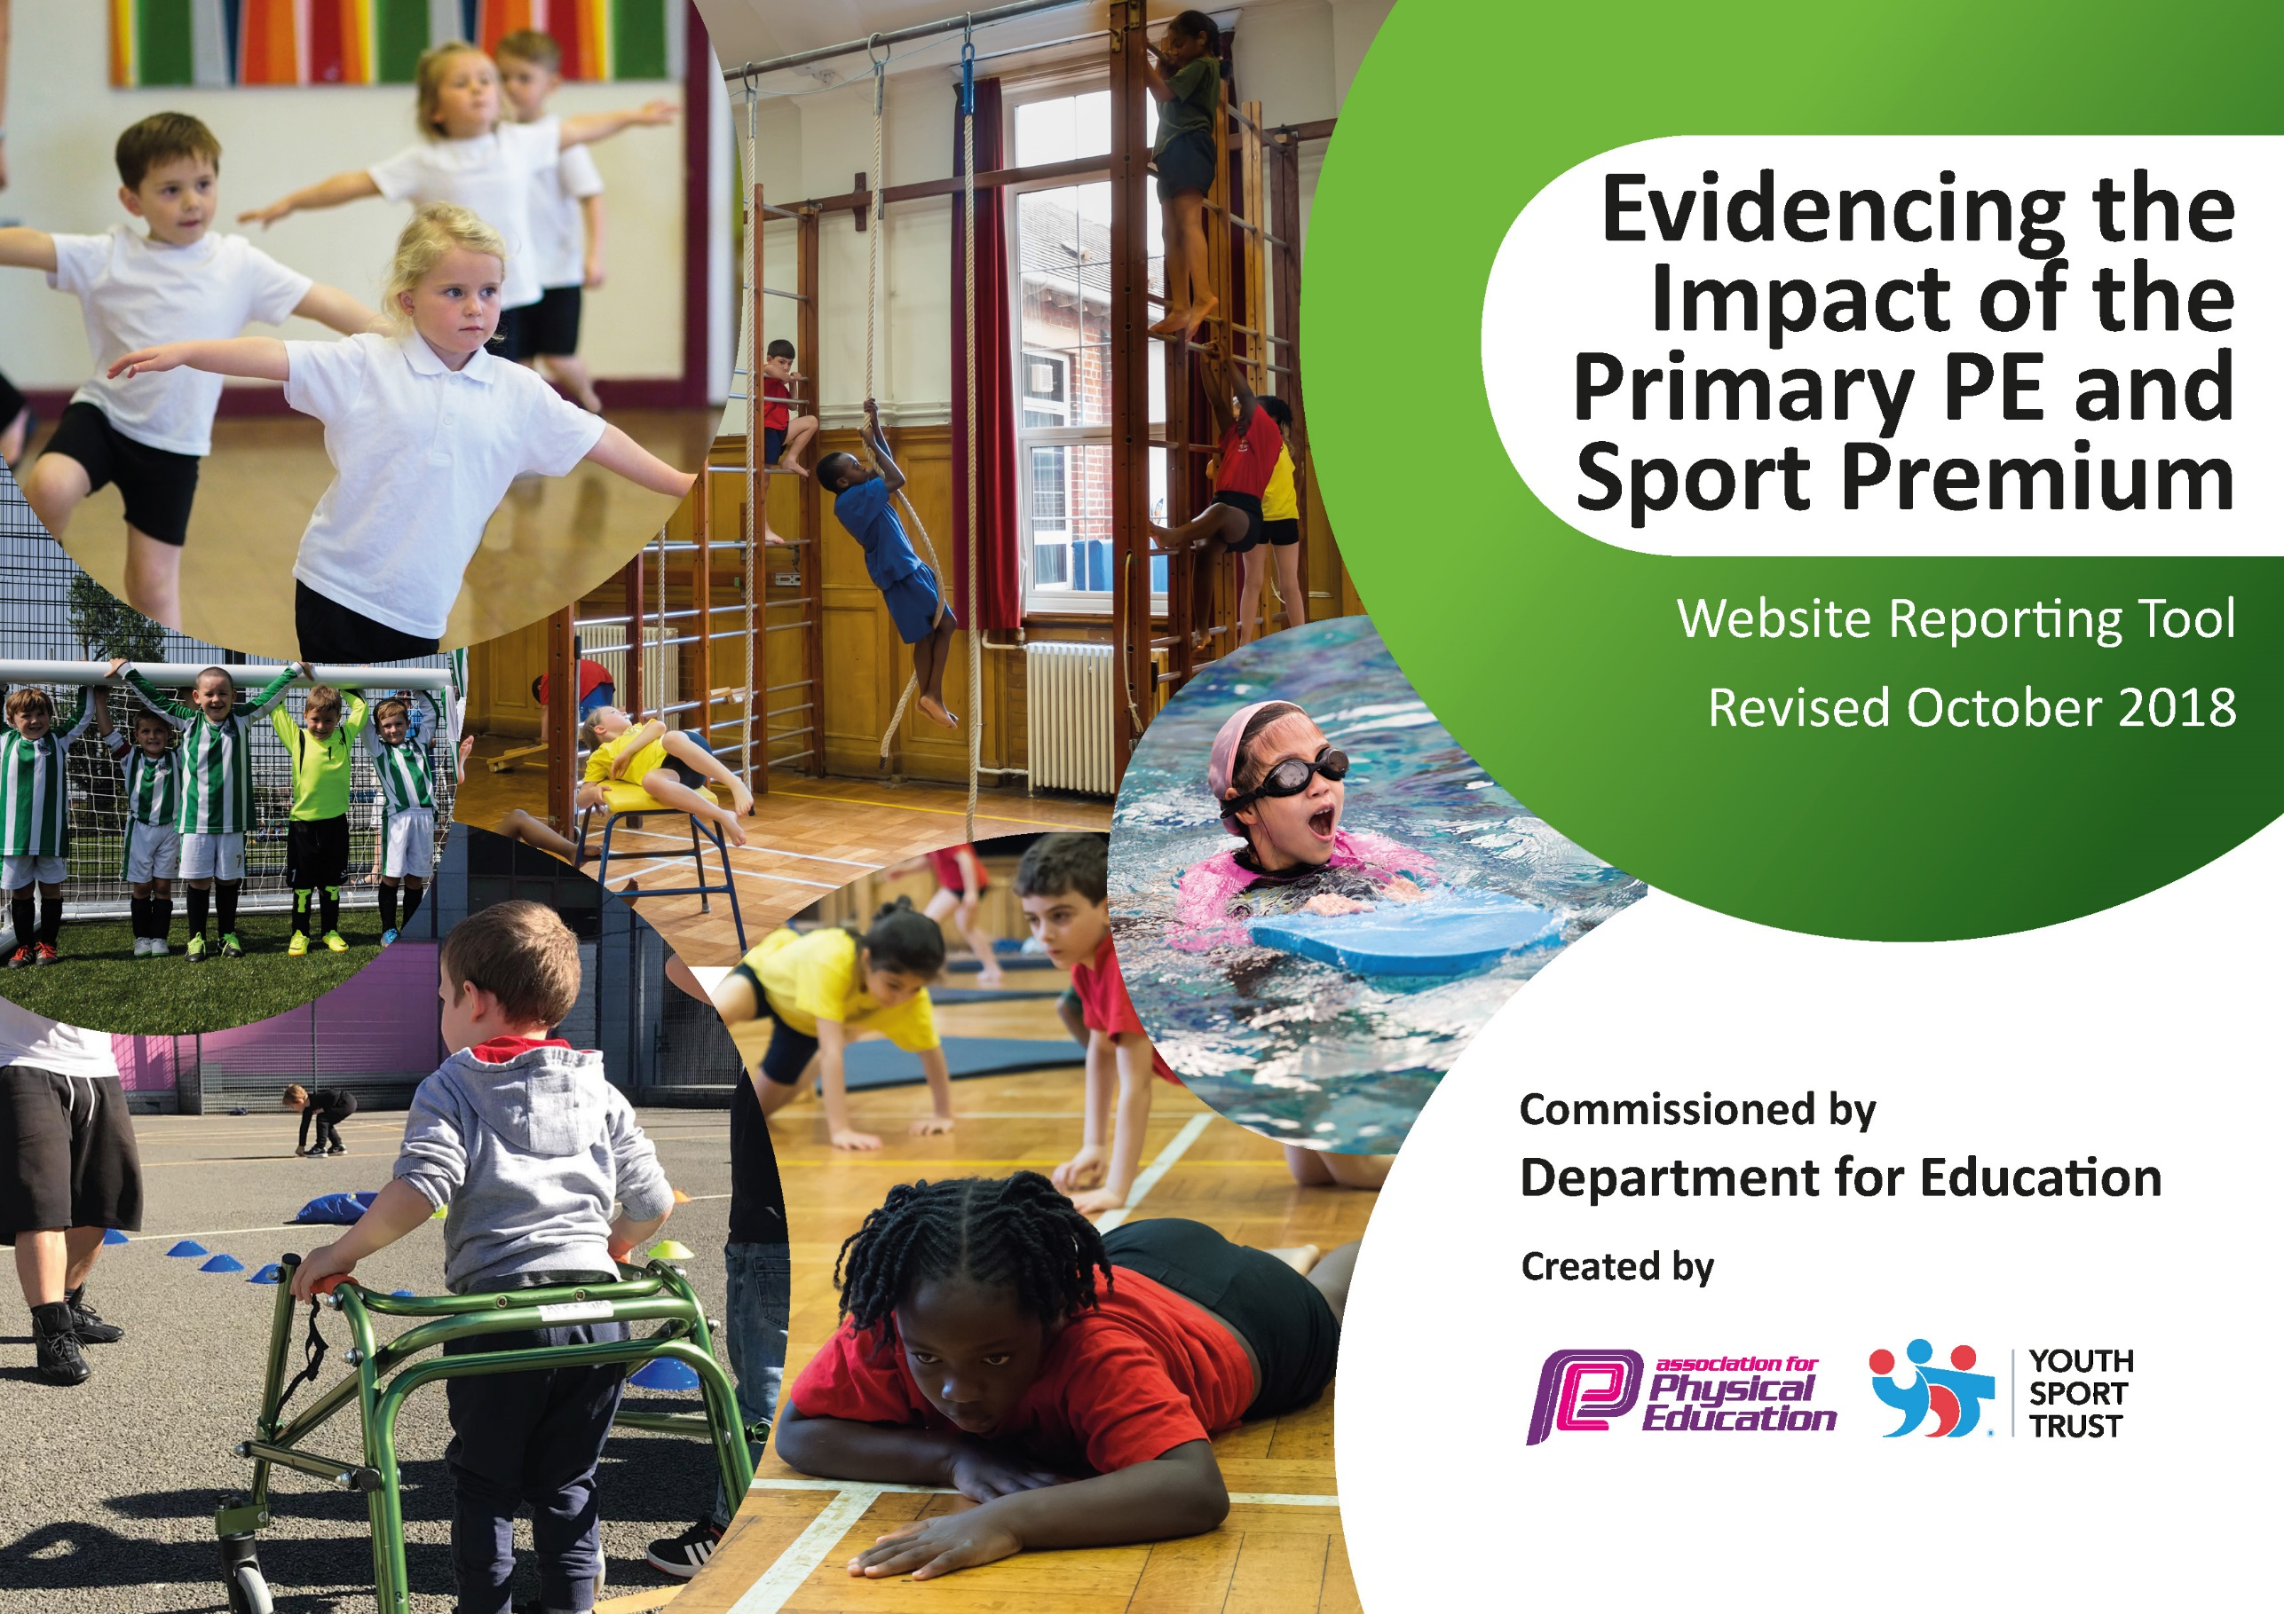
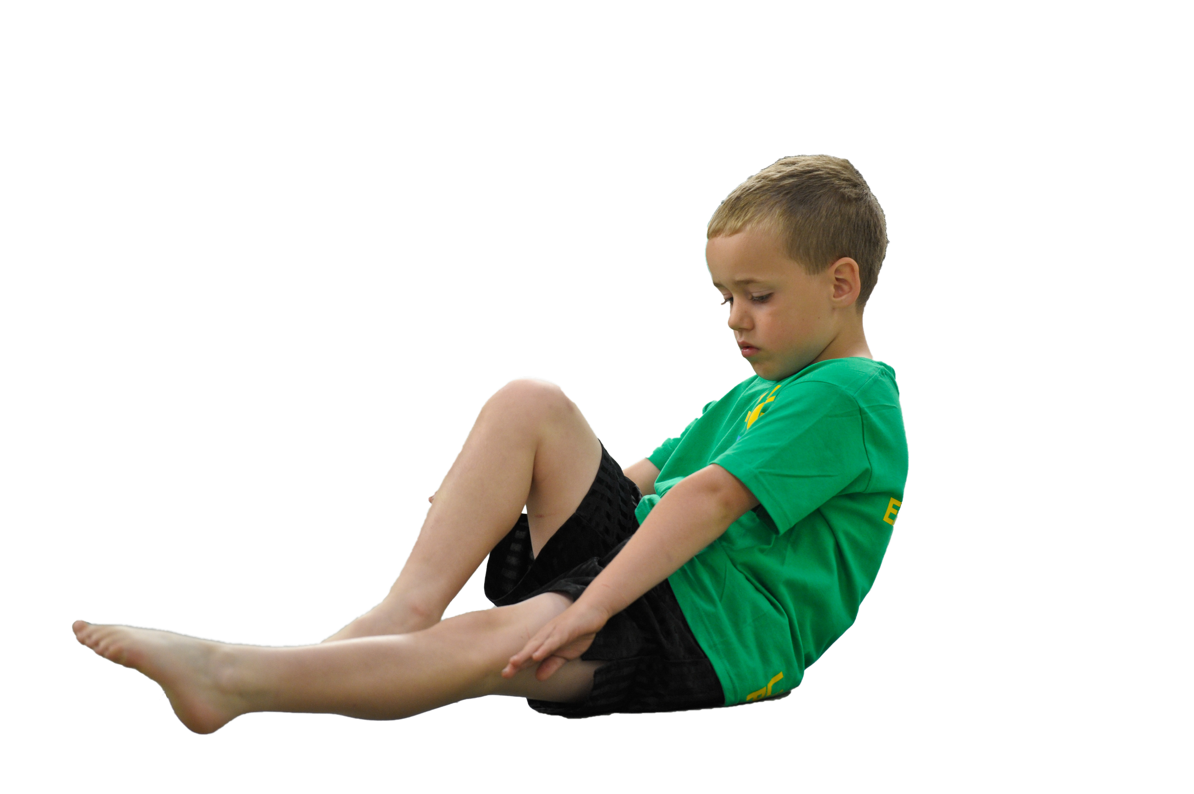
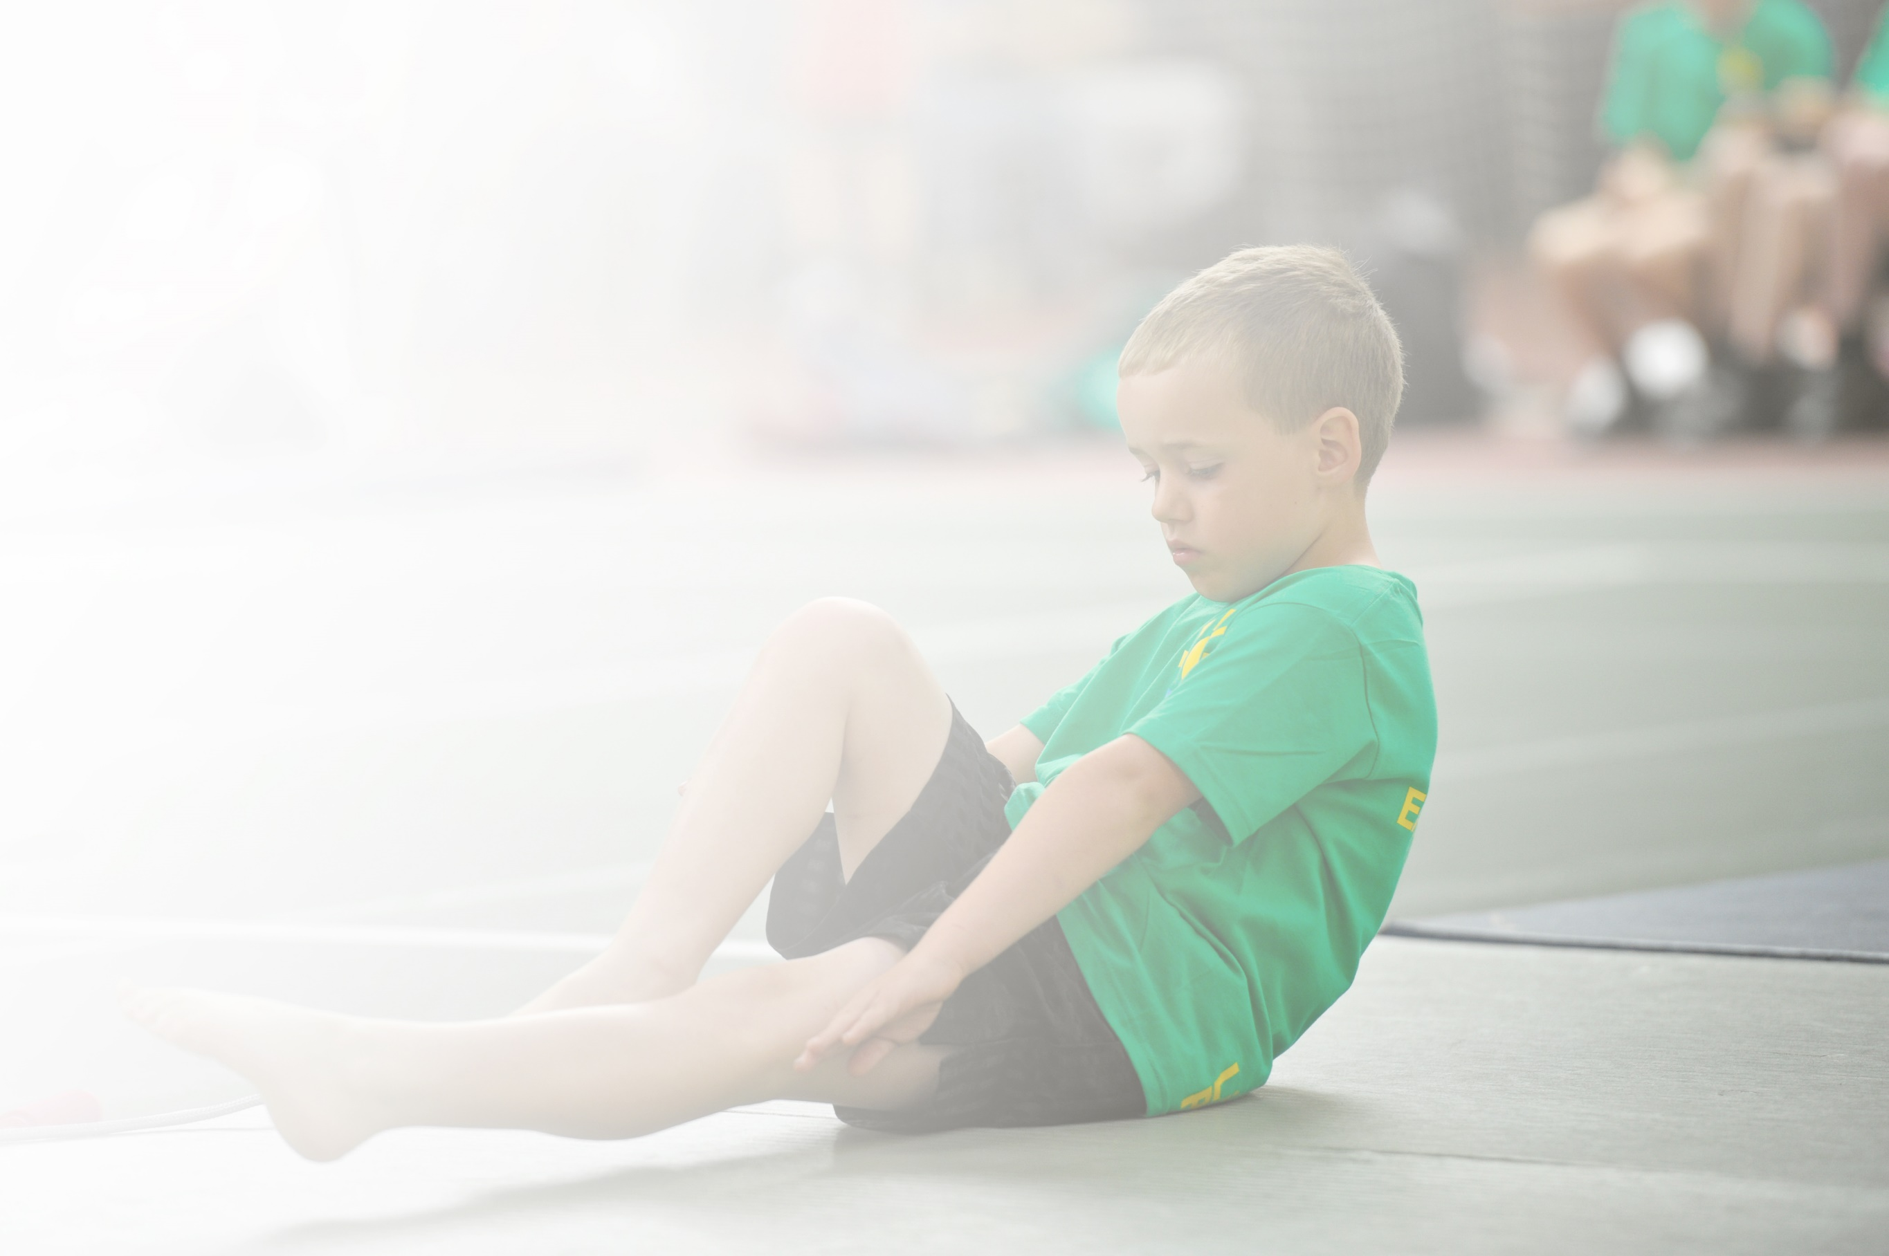
Schools must use the funding to make additional and sustainable improvements to the quality of Physical Education, Sport and Physical Activity (PESPA) they offer. This means that you should use the Primary PE and Sport Premium to:

- Develop or add to the PESPA activities that your school already offer
- Build capacity and capability within the school to ensure that improvements made now will benefit pupils joining the school in future years

Please visit gov.uk for the revised DfE guidance including the 5 key indicators across which schools should demonstrate an improvement. This document will help you to review your provision and to report
your spend. DfE encourages schools to use this template as an effective way of meeting the reporting requirements of the Primary PE and Sport Premium.

We recommend you start by reflecting on the impact of current provision and reviewing the previous
spend. Under the Ofsted Schools Inspection Framework, inspectors will assess how effectively leaders use the Primary PE and Sport Premium and measure its impact on outcomes for pupils, and how effectively governors hold them to account for this.

Schools are required to publish details of how they spend this funding as well as on the impact it has on pupils’ PE and sport participation and attainment by the end of the summer term or by 31 July 2019 at the
latest.
We recommend regularly updating the table and publishing it
on your website throughout the year, as evidence of your
ongoing review into how you are using the money to
secure maximum, sustainable impact. To see an
example of how to complete the table please
click HERE.

Support for review and reflection - considering the 5 key indicators from DfE, what development needs are a priority for your setting and your students now and why? Use the space below to reflect on previous spend, identify current need and priorities for the future.

Key achievements to date: | Areas for further improvement and baseline evidence of need:
Sports leads employed to deliver physical activity opportunities before, throughout and after the academy day and also holiday clubs  Sports rewards beginning to be implemented for children showing positive  sporting attitudes and behaviour  Sports Leaders trained and supporting other children at lunch and break times  More children accessing after school clubs  Children representing Middlesbrough in a range of events | Increase the range of activities delivered throughout the day  Increase the number of children leaving being able to swim 25m  Create more clubs for specific groups of children e.g healthy lifestyles

Meeting national curriculum requirements for swimming and water safety | Please complete all of the below:
What percentage of your current Year 6 cohort swim competently, confidently and proficiently over a distance of at least 25 metres?  N.B. Even though your children may swim in another year please report on their attainment on leaving  primary school. | 70%
What percentage of your current Year 6 cohort use a range of strokes effectively [for example, front crawl, backstroke and breaststroke]? | 58%
What percentage of your current Year 6 cohort perform safe self-rescue in different water-based situations? | 60%
Schools can choose to use the Primary PE and Sport Premium to provide additional provision for swimming but this must be for activity over and above the national curriculum requirements. Have you used it in this way? | No

Action Plan and Budget Tracking
Capture your intended annual spend against the 5 key indicators. Clarify the success criteria and evidence of impact that you intend to measure to evaluate for students today and for the future.

Academic Year: 2019/20 | Total fund allocated: £19110 | Date Updated: September 2019
Key indicator 1: The engagement of all pupils in regular physical activity – Chief Medical Officer guidelines recommend that primary school children undertake at least 30 minutes of physical activity a day in school |  |  |  | Percentage of total allocation:
 |  |  |  | %
School focus with clarity on intended impact on pupils: | Actions to achieve: | Funding allocated: | Evidence and impact: | Sustainability and suggested next steps:
More children who attend breakfast club will access physical activity  Equipment to support P.E provision/outdoor play equipment.  Organised physical activities will be led by adults at break time and lunchtime  Equipment will be available for children to use independently  Make links with local Sport clubs to give children more opportunities to excel within PE and Sport. | Look at organization and structure of breakfast club. How can more activity be led for all children together? More use of the cardio wall  Sports leads to set up organized activities at break and lunchtimes.  Stock take and order new equipment that children can use independently e.g. skipping ropes, bats, balls etc  Links made with local clubs with a positive impact for children. Links made with Pennyman and Brambles academies for future events. External events organized. | £1000  £1000  £2800  £2000 | Increase the amount of physical daily exercise and encourage healthy eating.  Children use balance equipment in conjunction with EYFS scheme of work to improve and then master basic skills needed to meet EYFS objectives. Children can take part in a range of sporting activities. Increase the amount of physical daily exercise and encourage healthy eating.  Specific sports groups including inclusive clubs- and on a lunchtime to accommodate more children | Increase the ercentage of children achieving ELG in Physical Development.  Consider the Funky Feet programme to compliment the physical movement programme already in place.  Staff to be upskilled and confident in delivering all aspects of EYFS P.E curriculum.  Additional PE lessons in place to increase the time allocated to physical exercise.
Key indicator 2: The profile of PESSPA being raised across the school as a tool for whole school improvement |  |  |  | Percentage of total allocation:
 |  |  |  | %
School focus with clarity on intended impact on pupils: | Actions to achieve: | Funding allocated: | Evidence and impact: | Sustainability and suggested next steps:
Professional athletes will work with the children to explain the opportunities sport has given them and the impact making the right choices can have.  Sports leaders are trained and used across the academy to encourage, model and motivate all children to participate in sport  Noticeboard to be developed to include photographs of sports leaders, teams of children who have represented the academy in competitions and also the results.  Take part in inter-school competitions across the area through the Middlesbrough Schools Sports Partnership. | Organise an assembly and sponsored event by a professional athlete to increase motivation and participation  Sports leaders to wear caps to identify the children and take a lead role in organising intra school sporting events  A team of staff to develop the board to make it engaging and child friendly. Displays in each year group.  A range of children to participate in organized competitions across the trust and sports partnerships. | £150  £200  £300  £400 | Sports leaders are in place on both KS1 and KS2 yards are more children are participating in organized activities. These are displayed in the corridors for all children to see.  Notice board is in place displaying results and achievements. Assemblies promote the achievements of children in sport both within and outside of school.  Events for KS1 and KS2 already planned and in place for Autumn term. | Begin training new sports leaders in the summer term ready for the next academic year.  Continued participation in Middlesbrough Schools Sports Partnership.

Key indicator 3: Increased confidence, knowledge and skills of all staff in teaching PE and sport |  |  |  | Percentage of total allocation:
 |  |  |  | %
School focus with clarity on intended  impact on pupils: | Actions to achieve: | Funding  allocated: | Evidence and impact: | Sustainability and suggested  next steps:
Improved role modelling of healthy active lifestyle behaviours by all school staff to reach all children.  Use a specialist dance teacher to teach the dance curriculum and improve staff confidence in delivering in this area.  To increase physical activity through outdoor learning.  Use qualified swimming teachers in school to teach swimming | Staff to wear appropriate clothing and participate in PE sessions and activities when modelling skills. Healthy eating alongside activity to be a focus for the JLT. Include photos of staff participating in activity and eating healthily.  Organise a specialist dance teacher to deliver the dance curriculum to year groups. Staff repeat some of the activities in their own sessions.  Teachers to plan physical activity during outdoor learning.  Use sports leaders to teach swimming alongside qualified instructors and develop the knowledge of class teachers. Supply teachers to cover sessions staff are not in school. | £400  £1500  £1200 | New kit bought for staff and the expectation this is worn when teaching PE.  New kit for Sports Leads to be purchased.  Dance teacher booked to work with different year groups throughout the year. | to include activities where parents can join in alongside their child.
Key indicator 4: Broader experience of a range of sports and activities offered to all pupils |  |  |  | Percentage of total allocation:
 |  |  |  | %
School focus with clarity on intended  impact on pupils: | Actions to achieve: | Funding  allocated: | Evidence and impact: | Sustainability and suggested  next steps:
Additional achievements:  A wider range of after school clubs, holiday clubs, reward activities and visitors into school will allow children the opportunity to access more sports  To support all children in developing their skill levels across the curriculum map.  To support Gifted and Talented children and give them a platform to progress even further within sport.  Specific activities for children with SEND to allow accessibility for all | Create a database of clubs children would like to attend alongside places allocated so children access a range of activities throughout the year. Arrange lunchtime clubs to allow children who do not access out of schools clubs an opportunity. Create general ability clubs alongside specific G&T clubs Offering children across both EYFS, KS1 and KS2 a wide variety of skills and different sports.  Working closely with the children who display potential, helping them to improve their skill levels.  Activities planned specifically to allow all children to access.  Set up specific clubs for G&T children in different sports. Enter different competitions to challenge.  Access SEND specific competitions/activities | £1780  £2000  £300  £300 | Ice skating for SEND groups in a supportive and inclusive manner. | Raise awareness of staff as to the range of clubs provided in the local area. This will allow children to be signposted to clubs meeting their interest or requirements.
Key indicator 5: Increased participation in competitive sport |  |  |  | Percentage of total allocation:
 |  |  |  | %
School focus with clarity on intended  impact on pupils: | Actions to achieve: | Funding  allocated: | Evidence and impact: | Sustainability and suggested  next steps:
Children of different age ranges to compete in a range of sports in competitive sports competitions through School Sport partnership cluster throughout the year.  Organise inter-schools competitions in a range of sports  Through Middlesbrough Sports Partnership and Youth Sports, enter a range of competitions for children across the key stages.  In addition to competitions already organized, arrange competitions through Pennyman for children to attend in different sports. | Through Middlesbrough Sports Partnership and Youth Sports, enter a range of competitions for children across the key stages.  addition to competitions already organized, arrange competitions through Pennyman for children to attend in different sports.  Children will participate in intra sports competitions appropriate to the curriculum map. | £1000 partnership cost £1000 transport costs  £300 venue costs |  | Increased awareness of staff in the academy to provide a wide range of opportunities for children to participate in competitive sport. Increase links with local clubs.

